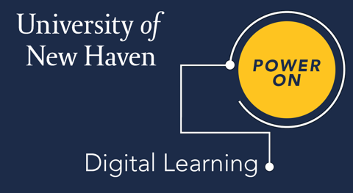

**Core Components for University of New Haven Online and Canvas Courses**

These guidelines provide an outline of key components for an online course to increase student engagement and retention.

# Syllabus

Use College/School templates in MyCharger: <https://facultysupport.newhaven.edu/syllabus-templates/>

1. **Home Page**

General information such as the course title and description. Professor information and contact information.

# Learning Outcomes & Alignment

Measurable learning outcomes for each module that map to the learning content and the assessments.

# Module Introductions

Introductory videos (Mini lecture videos are highly recommended for weekly topics.) or text-based introductions highlighting each week and/or summarizing the previous week.

1. **Interactive Elements/Digital Assets**

Interactive elements can include case studies, gamification, interactive content with check on learnings, video quizzes, etc. Please visit our library of assets for ideas at digitallearning.newhaven.edu

# Module Learning Content and Development

Modules should be made up of multiple modes of learning content including instructor lead text, video, and context for assets in the course. Publisher materials should be followed with instructor/developer context. Implement a Universal Design approach to meet inclusivity of students. All content needs to follow intellectual property guidelines.

# Assignments/Assessments

These demonstrate student learning and should align with the course and module outcomes and must be measurable. Authentic assessments and AI proof assignments are encouraged.

* + **Rubrics** are suggested for major assignments. They are required for the School of Health Sciences.

1. **Discussions & Peer to Peer Engagement** (For fully online asynchronous courses)

These are critical for faculty to facilitate student engagement for online courses. This is a tool for faculty to ensure that there is regular and substantive interaction between faculty and students in an online course. Discussions allow for both faculty to student as well as student to student engagement.

Alternatively, group work can be assigned to ensure student to student interaction. Student to student interaction is a requirement for accreditation.

# Grades

All grades and assignments must reside in Canvas for student continuity and academic record.

# ADA Compliance

Courses should include closed captioning and be in line with ADA standards. Instructional designers will take the lead in advising in this area. Canvas has tools to assist with ADA compliance.

Resources to support online learning may be found within our [*Digital Learning web site*](https://digitallearning.newhaven.edu/) Please contact [*DigitalLearning@newhaven.edu*](mailto:DigitalLearning@newhaven.edu)to have our online template placed in your course.

Rev. 10/2024